HIVE_ Assignment3_ANUP_PATIL  
  
Q1  
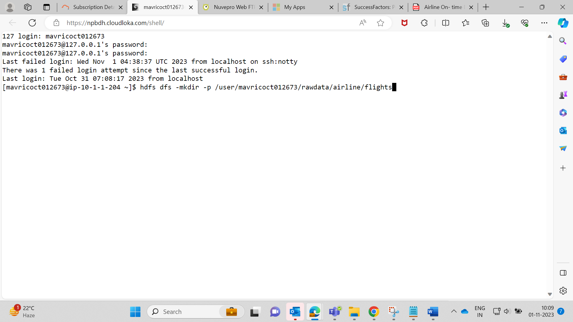

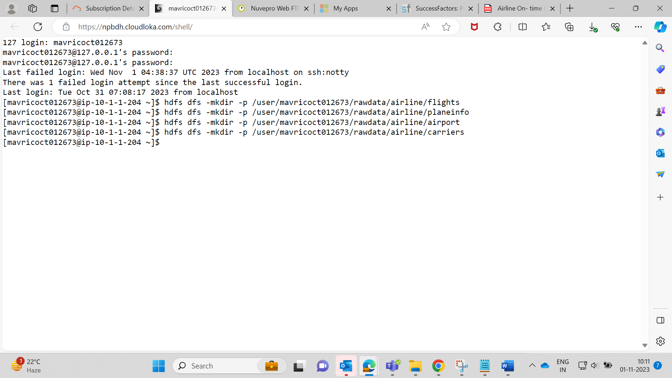

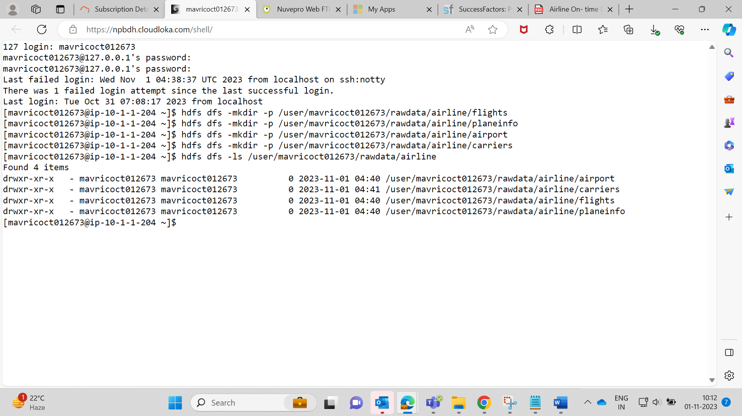  
  
  
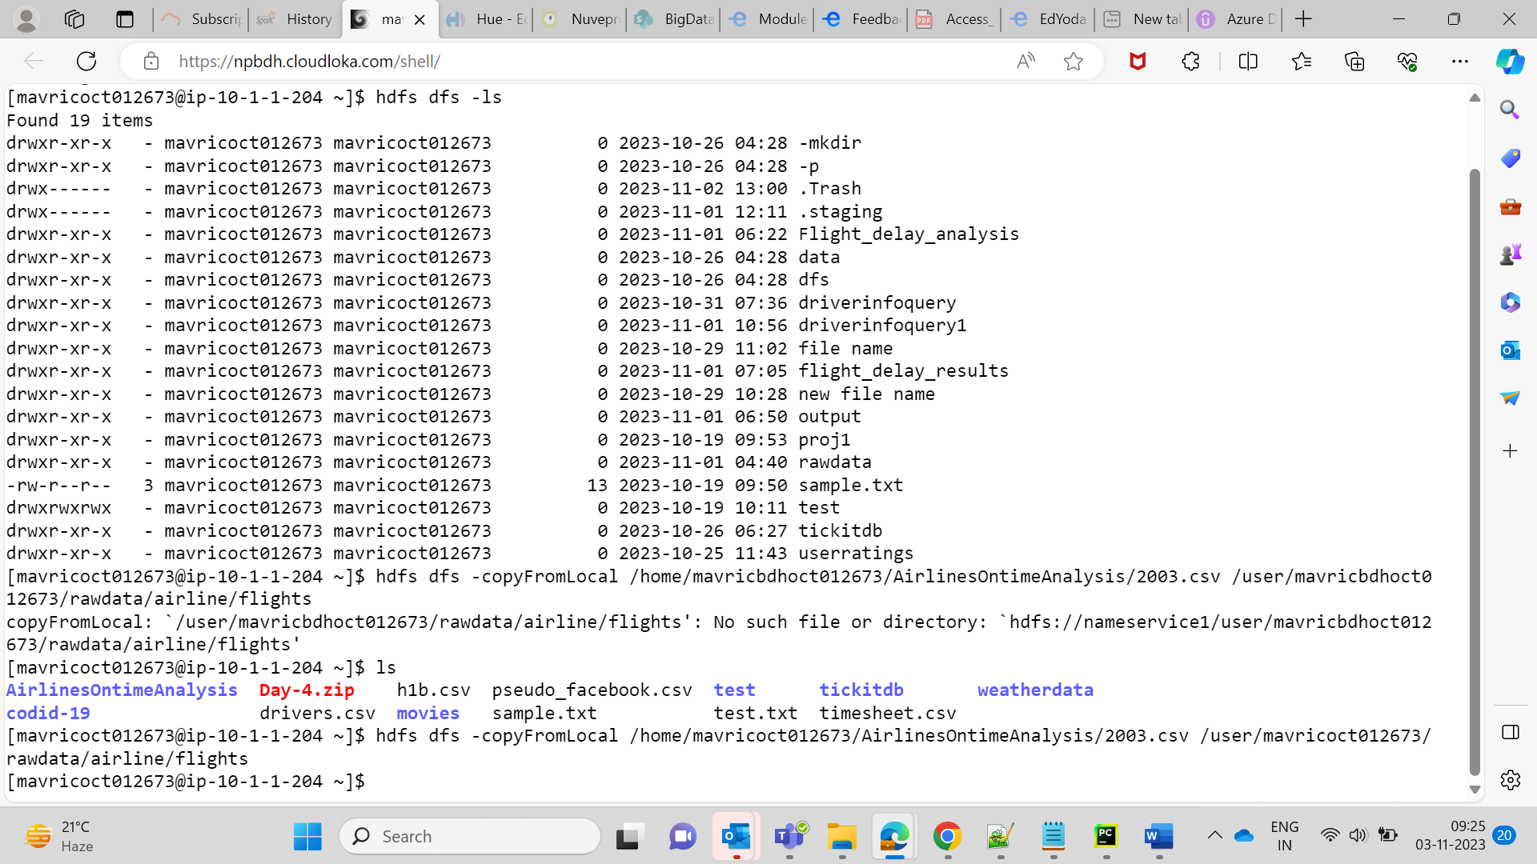

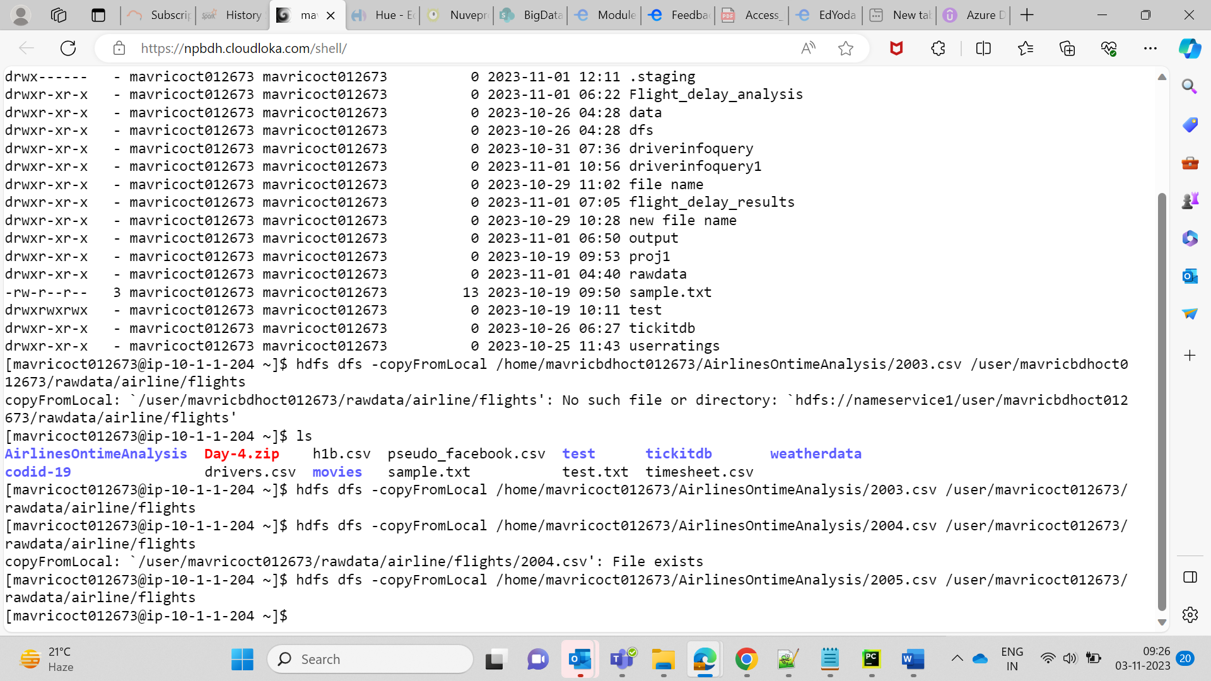  
  
  
Q2.

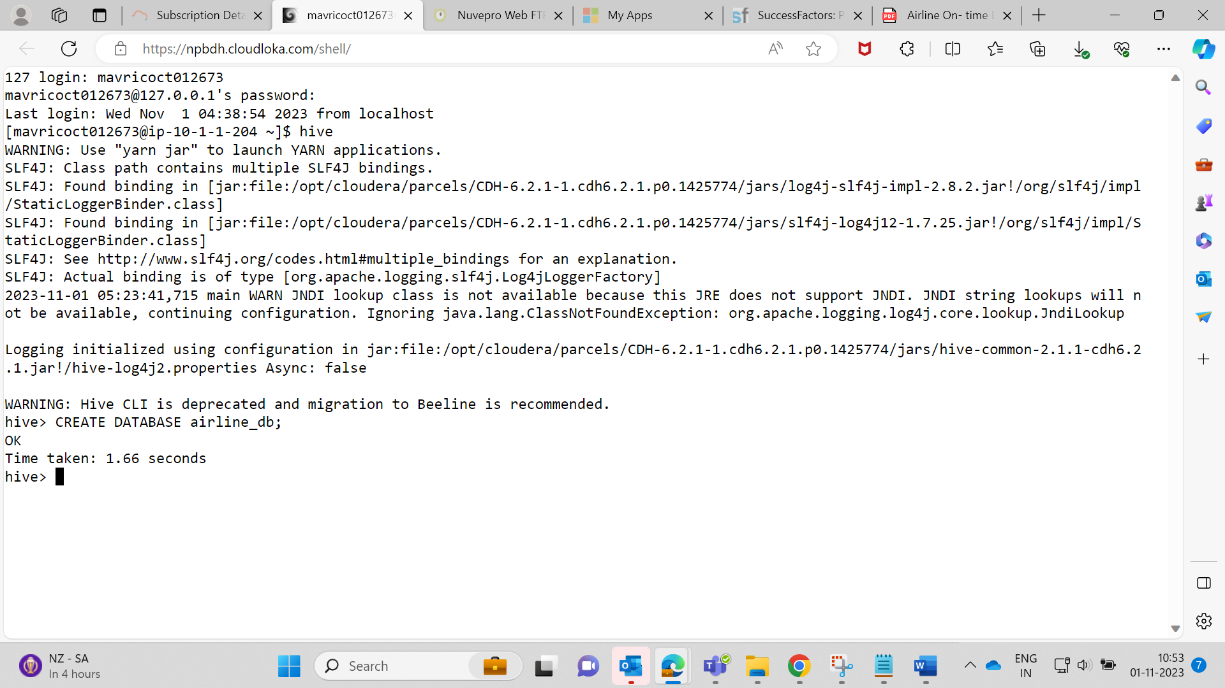

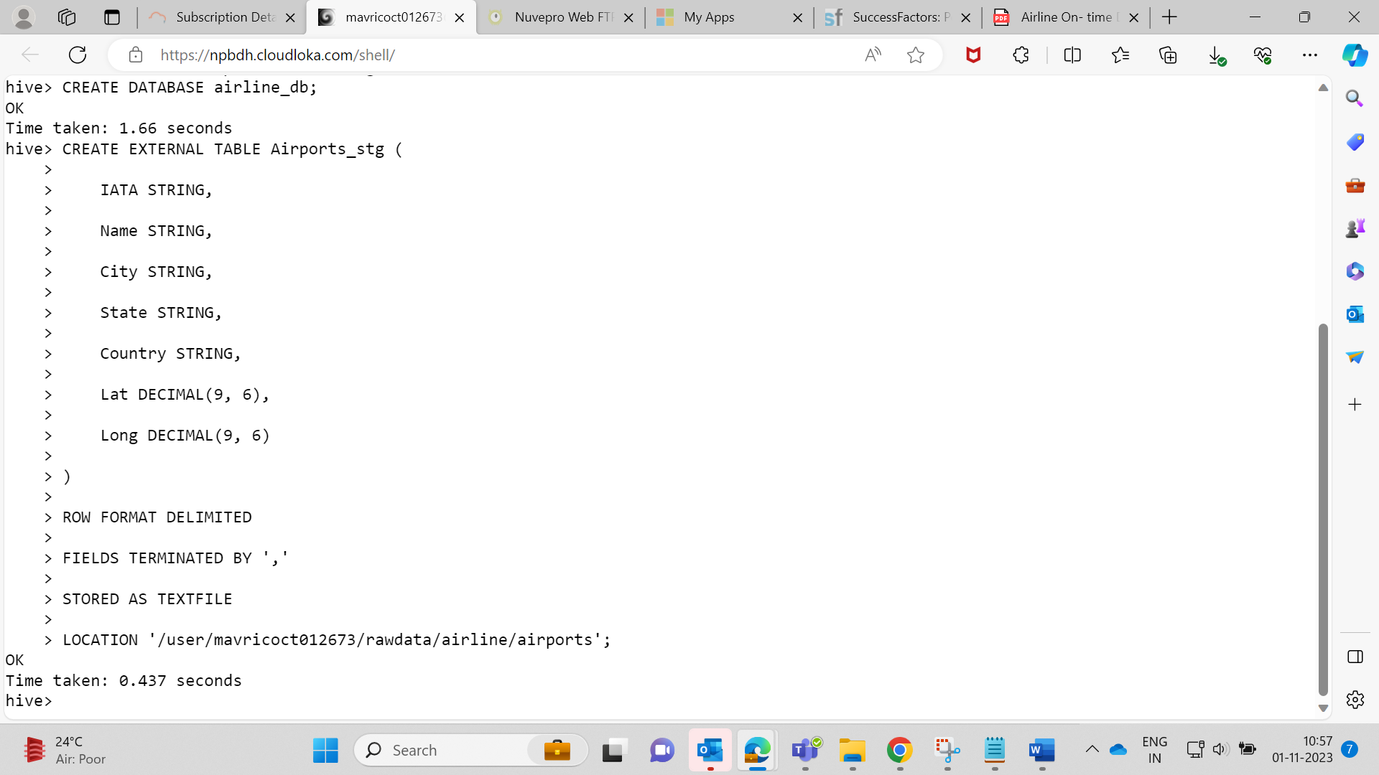

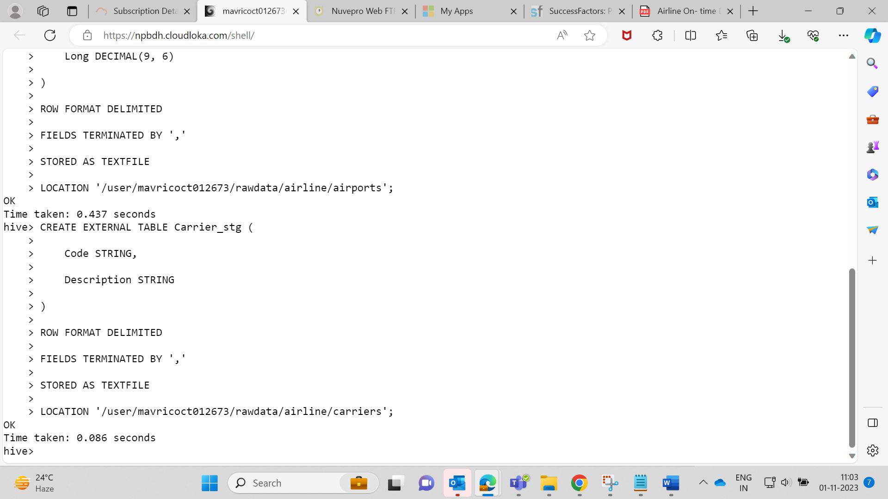  
  
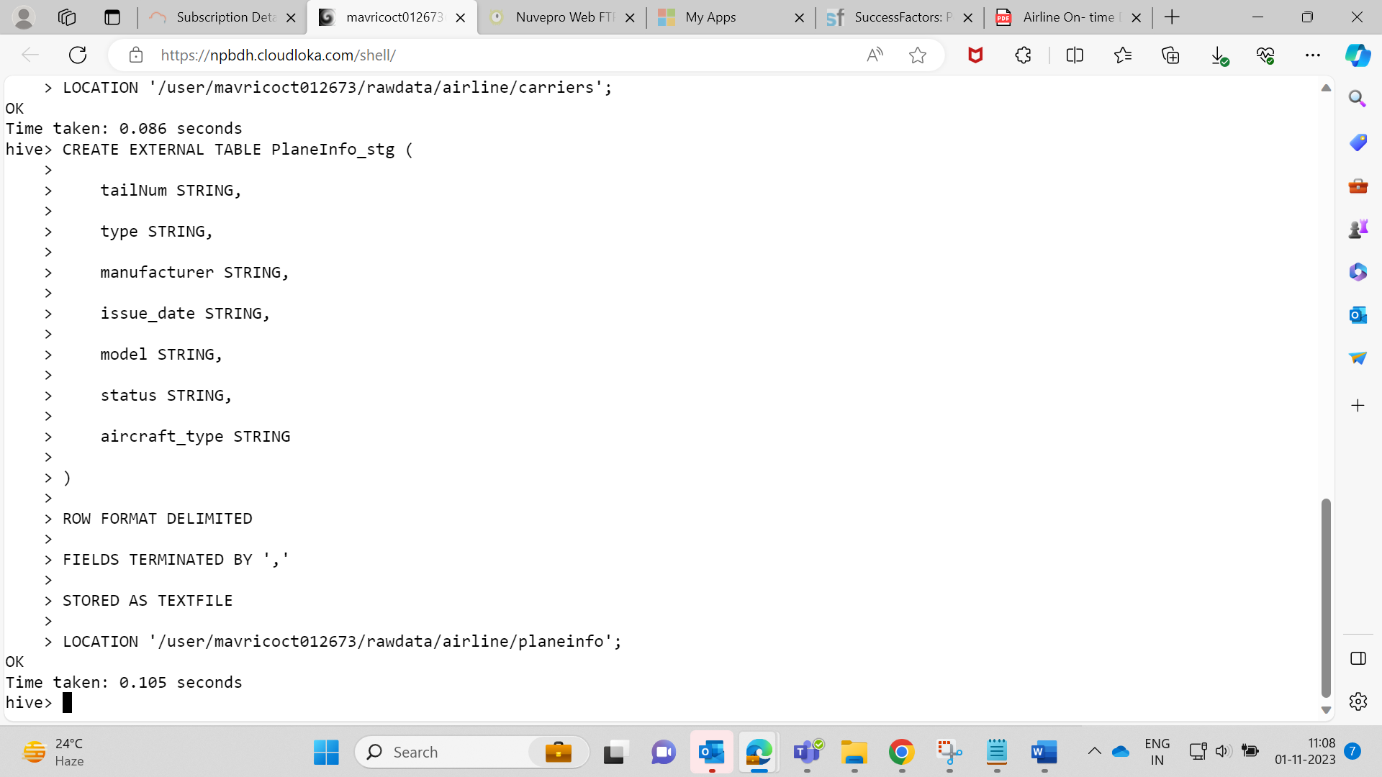  
  
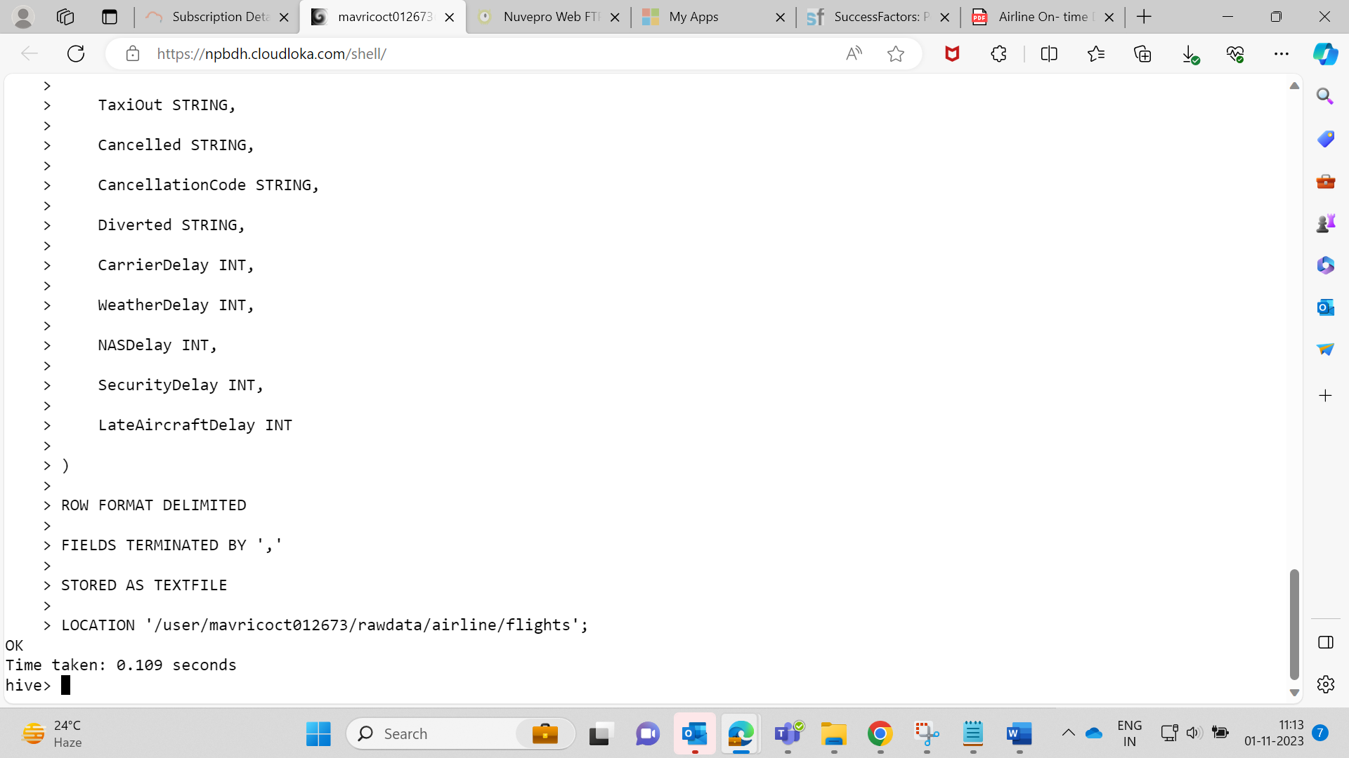  
  
Created All 4 External Tables -  
  
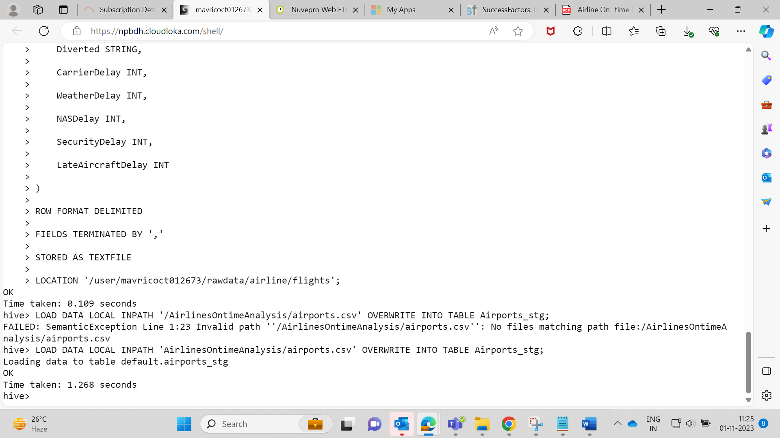

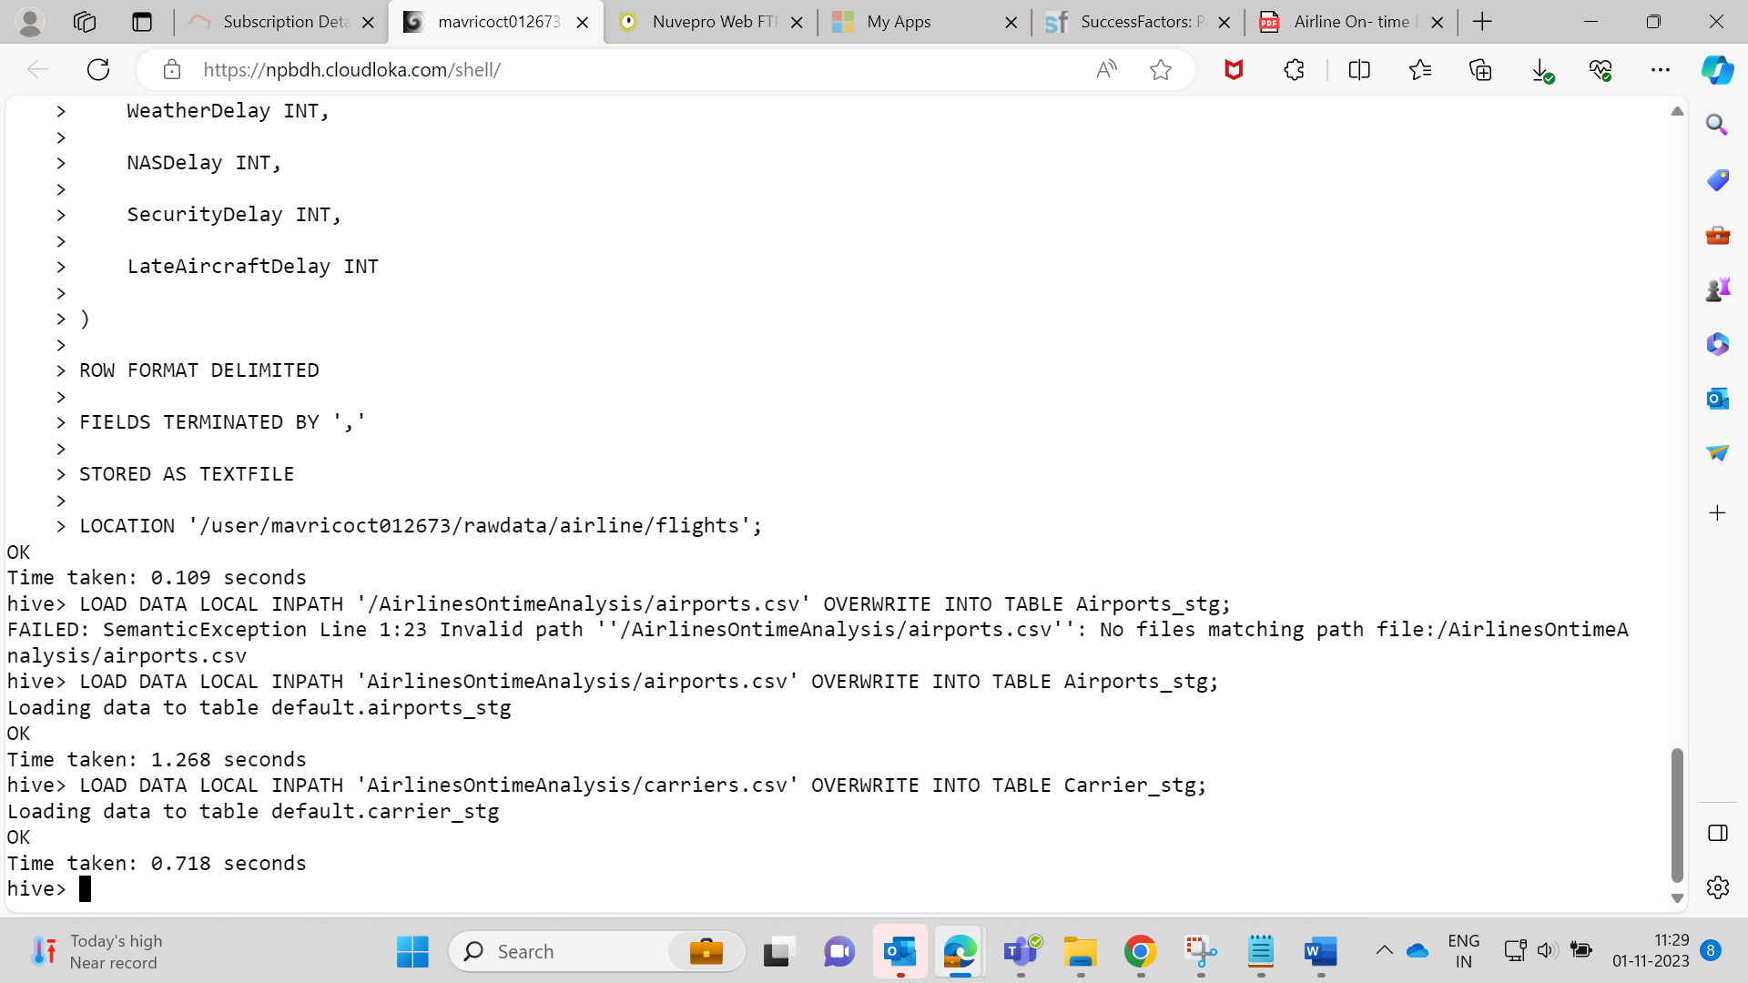

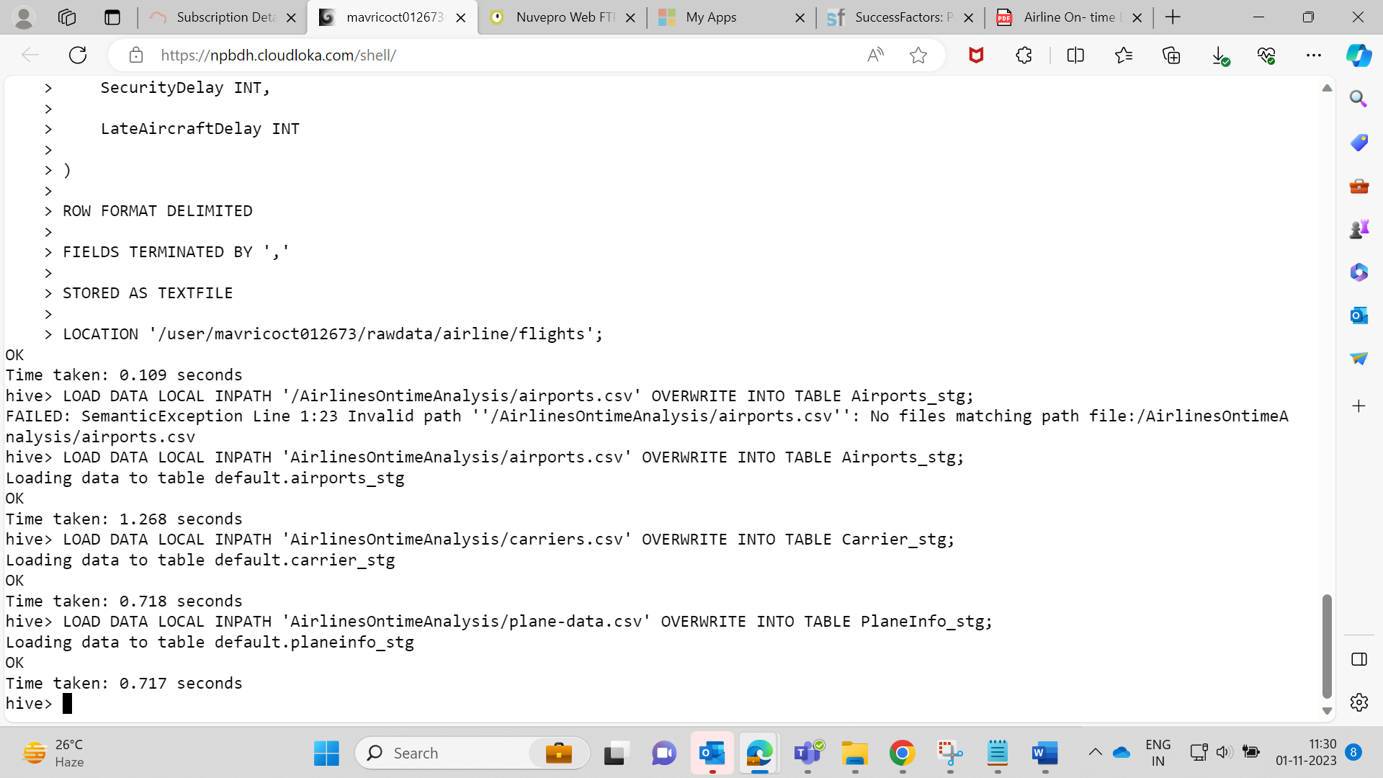

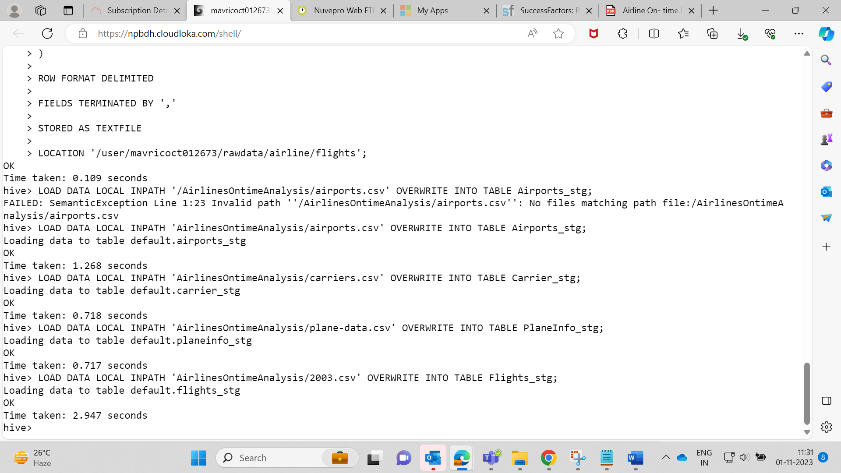

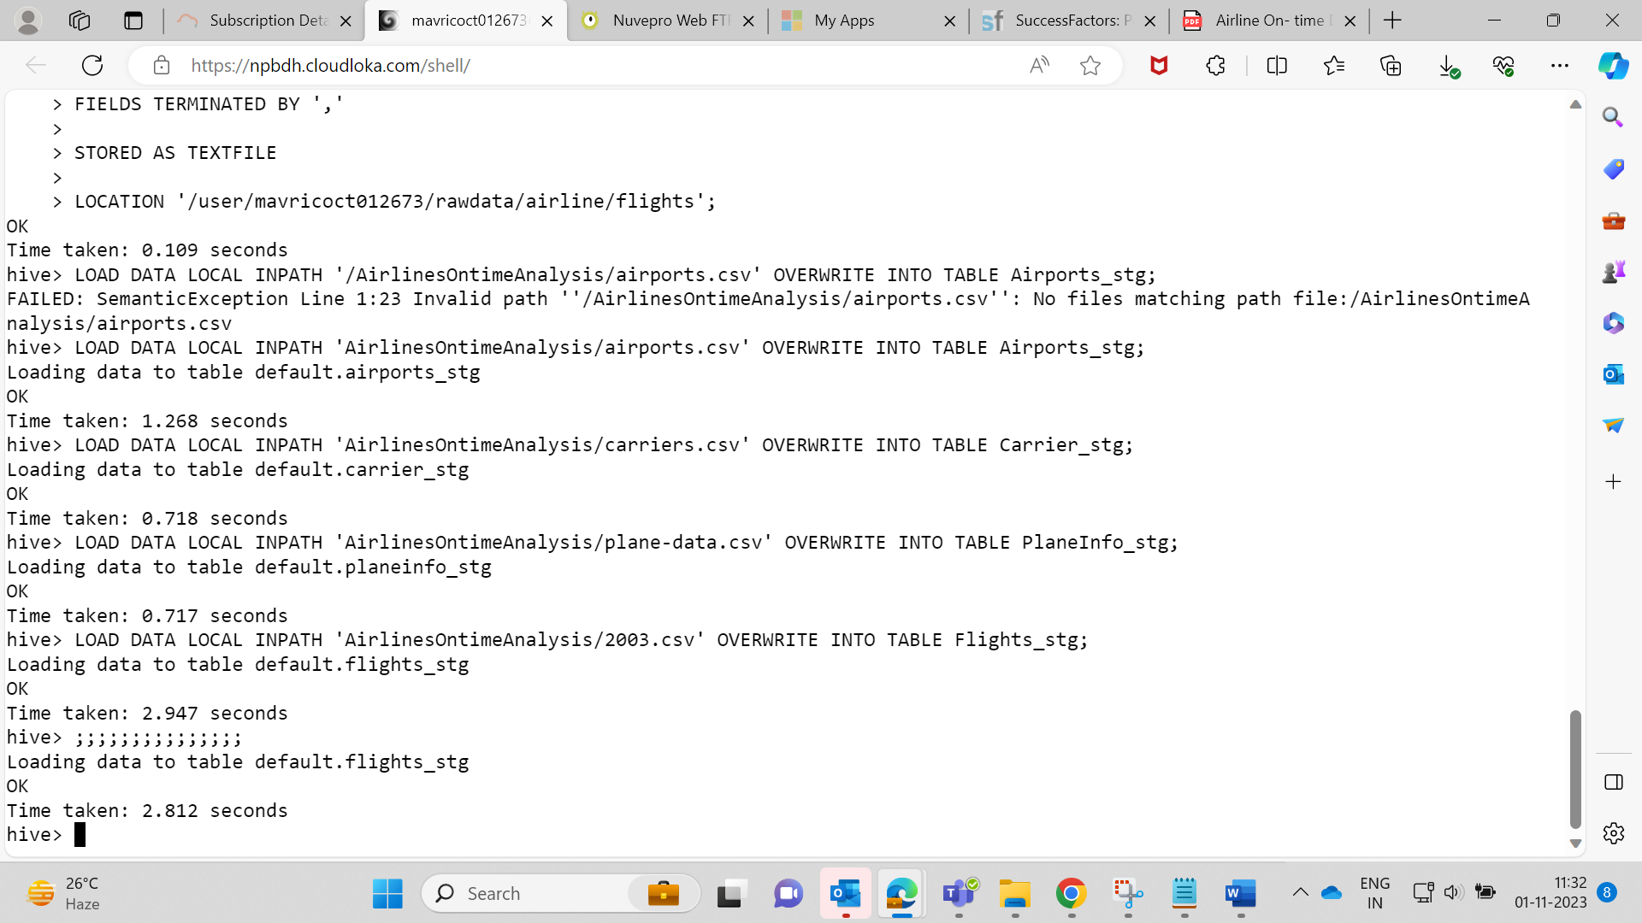  
  
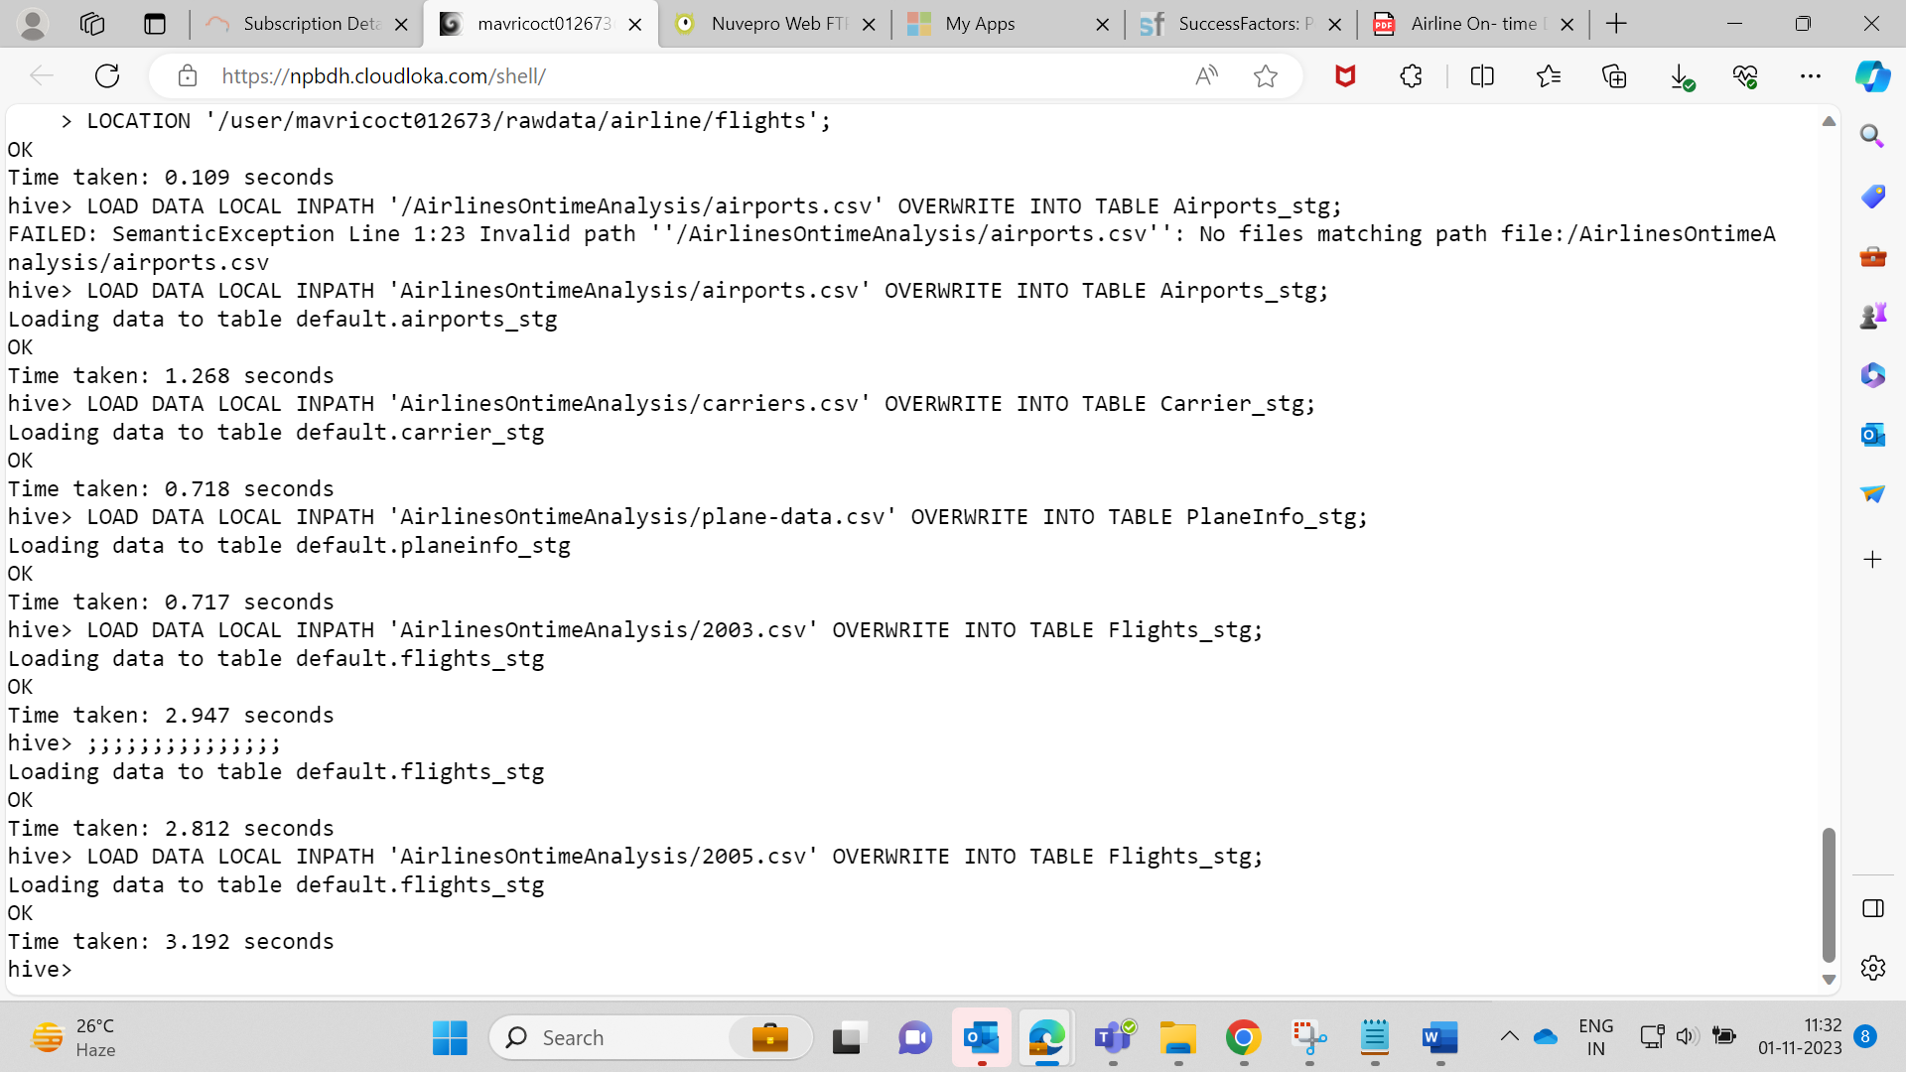  
LOAD DATA LOCAL INPATH 'AirlinesOntimeAnalysis/airports.csv' OVERWRITE INTO TABLE Airports_stg;

LOAD DATA LOCAL INPATH 'AirlinesOntimeAnalysis/carriers.csv' OVERWRITE INTO TABLE Carrier_stg;

LOAD DATA LOCAL INPATH 'AirlinesOntimeAnalysis/plane-data.csv' OVERWRITE INTO TABLE PlaneInfo_stg;

LOAD DATA LOCAL INPATH 'AirlinesOntimeAnalysis/2003.csv' OVERWRITE INTO TABLE Flights_stg;

LOAD DATA LOCAL INPATH 'AirlinesOntimeAnalysis/2004.csv' OVERWRITE INTO TABLE Flights_stg;

LOAD DATA LOCAL INPATH 'AirlinesOntimeAnalysis/2005.csv' OVERWRITE INTO TABLE Flights_stg;  
  
**Describe Table-**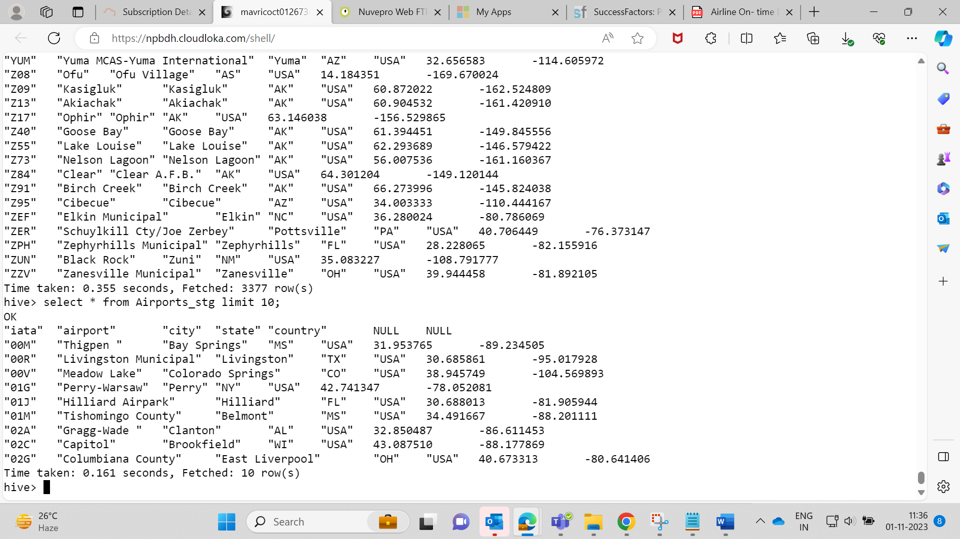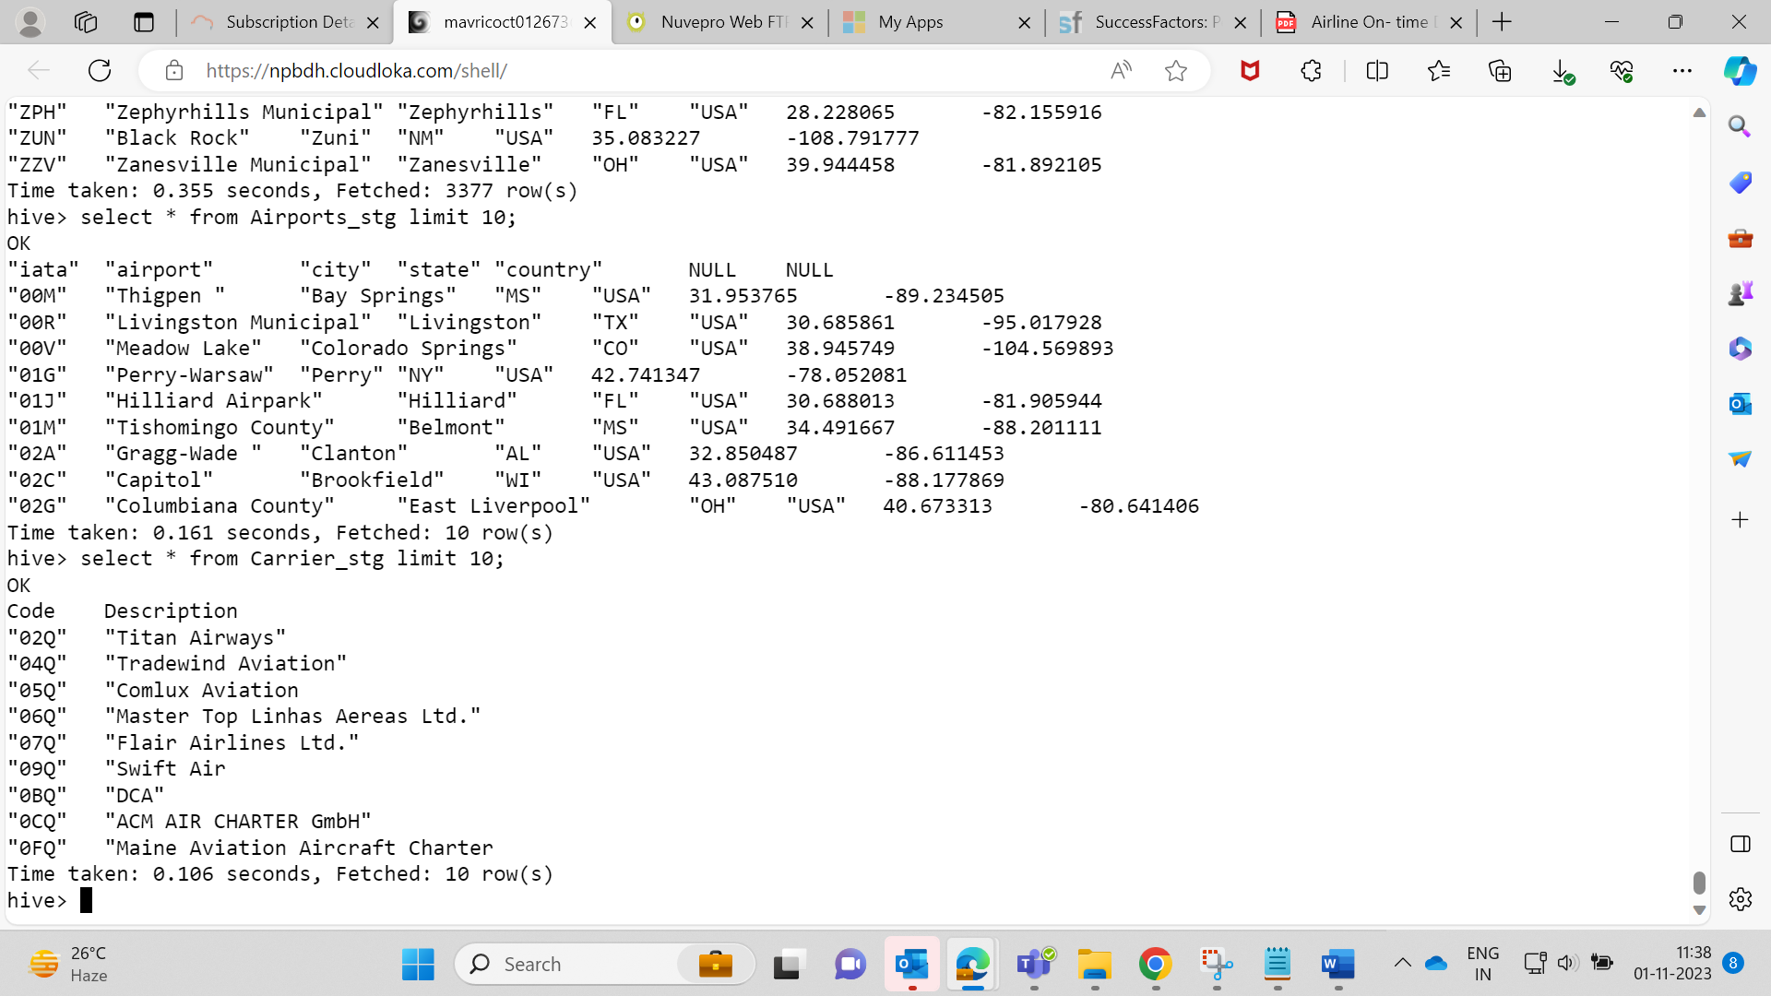

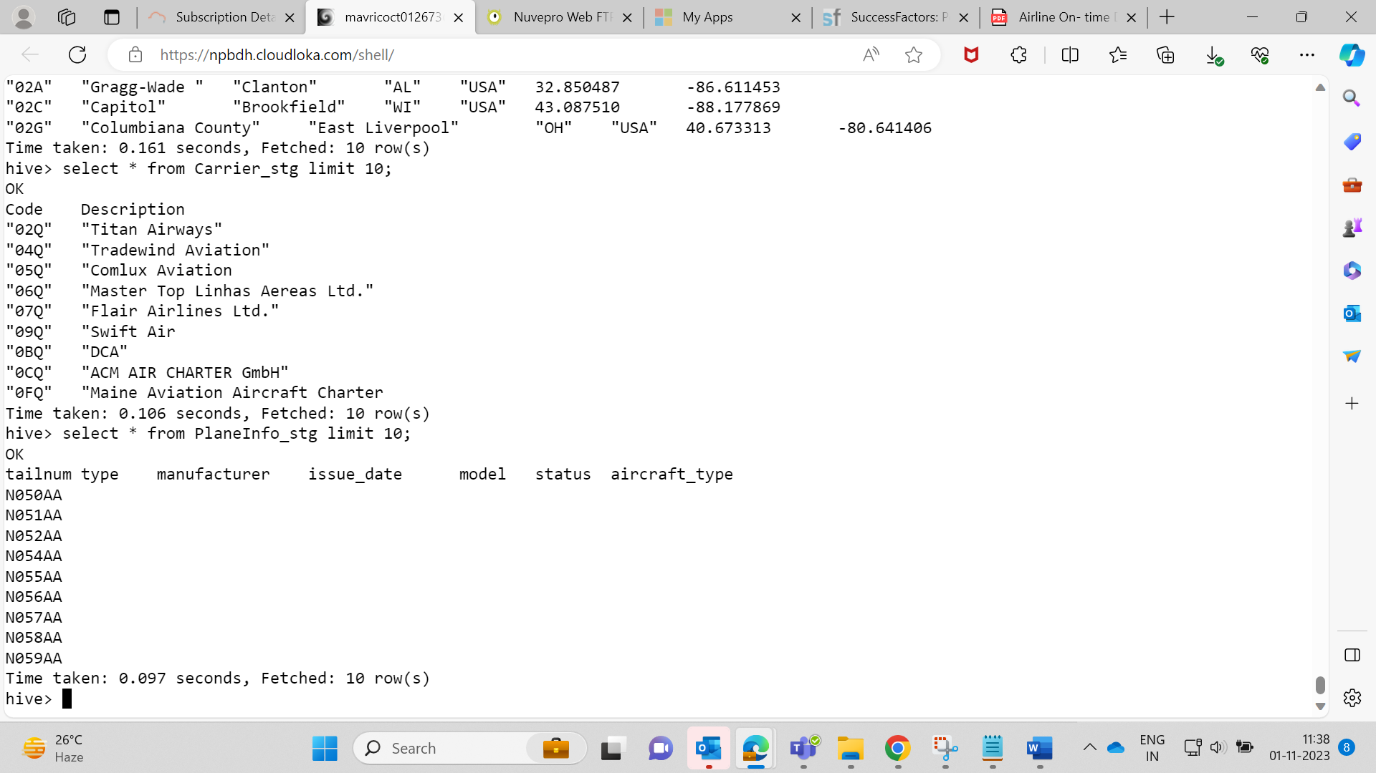  
  
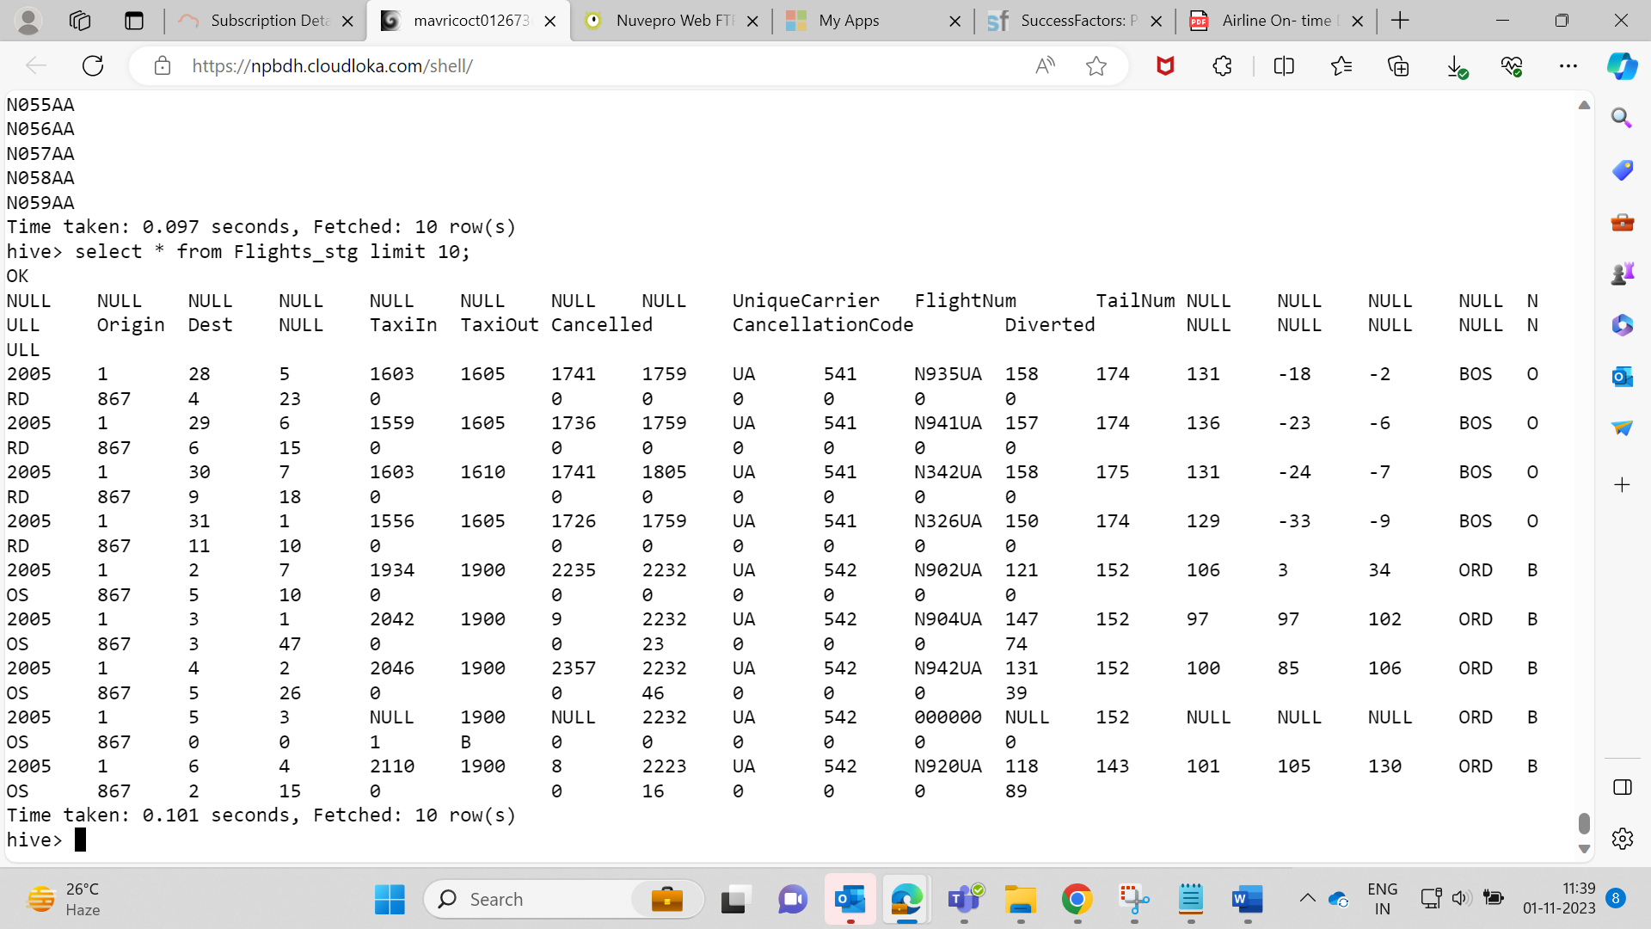  
  
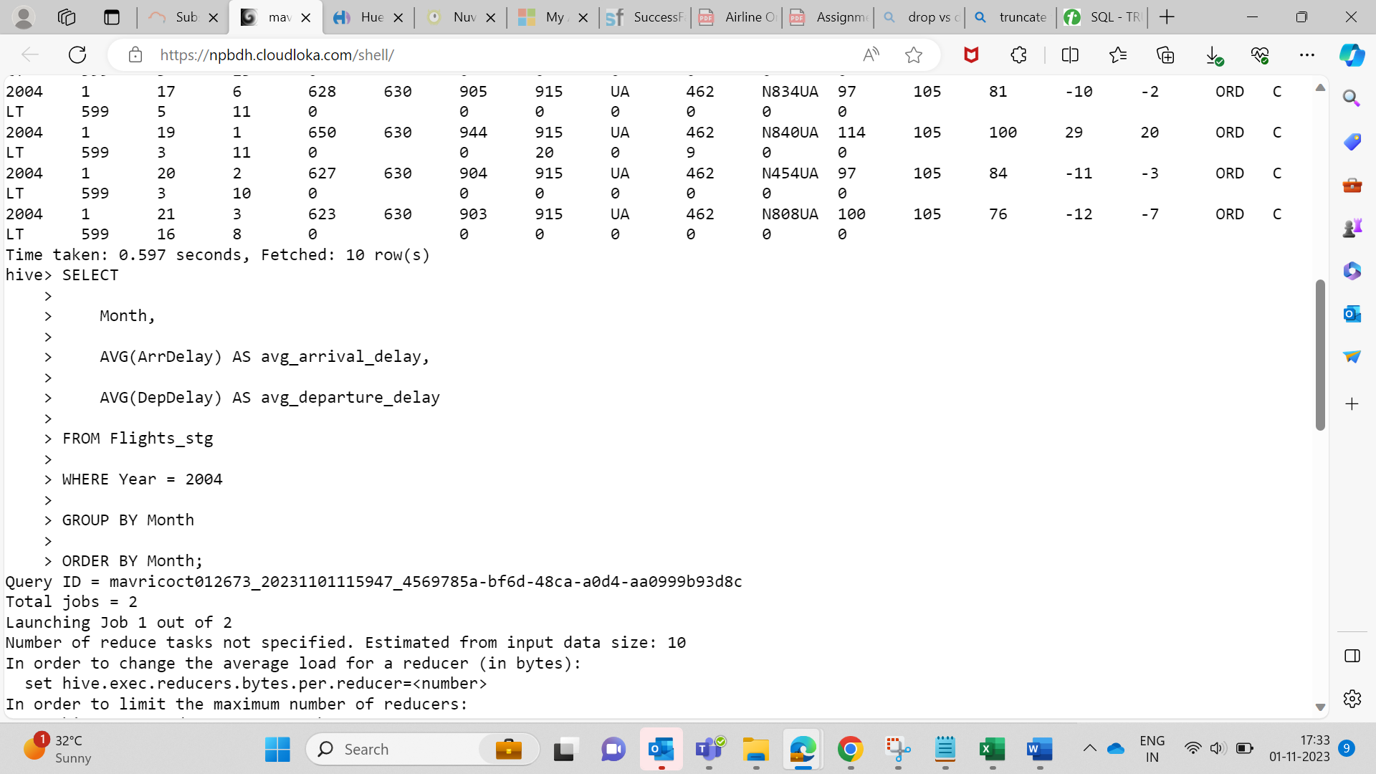

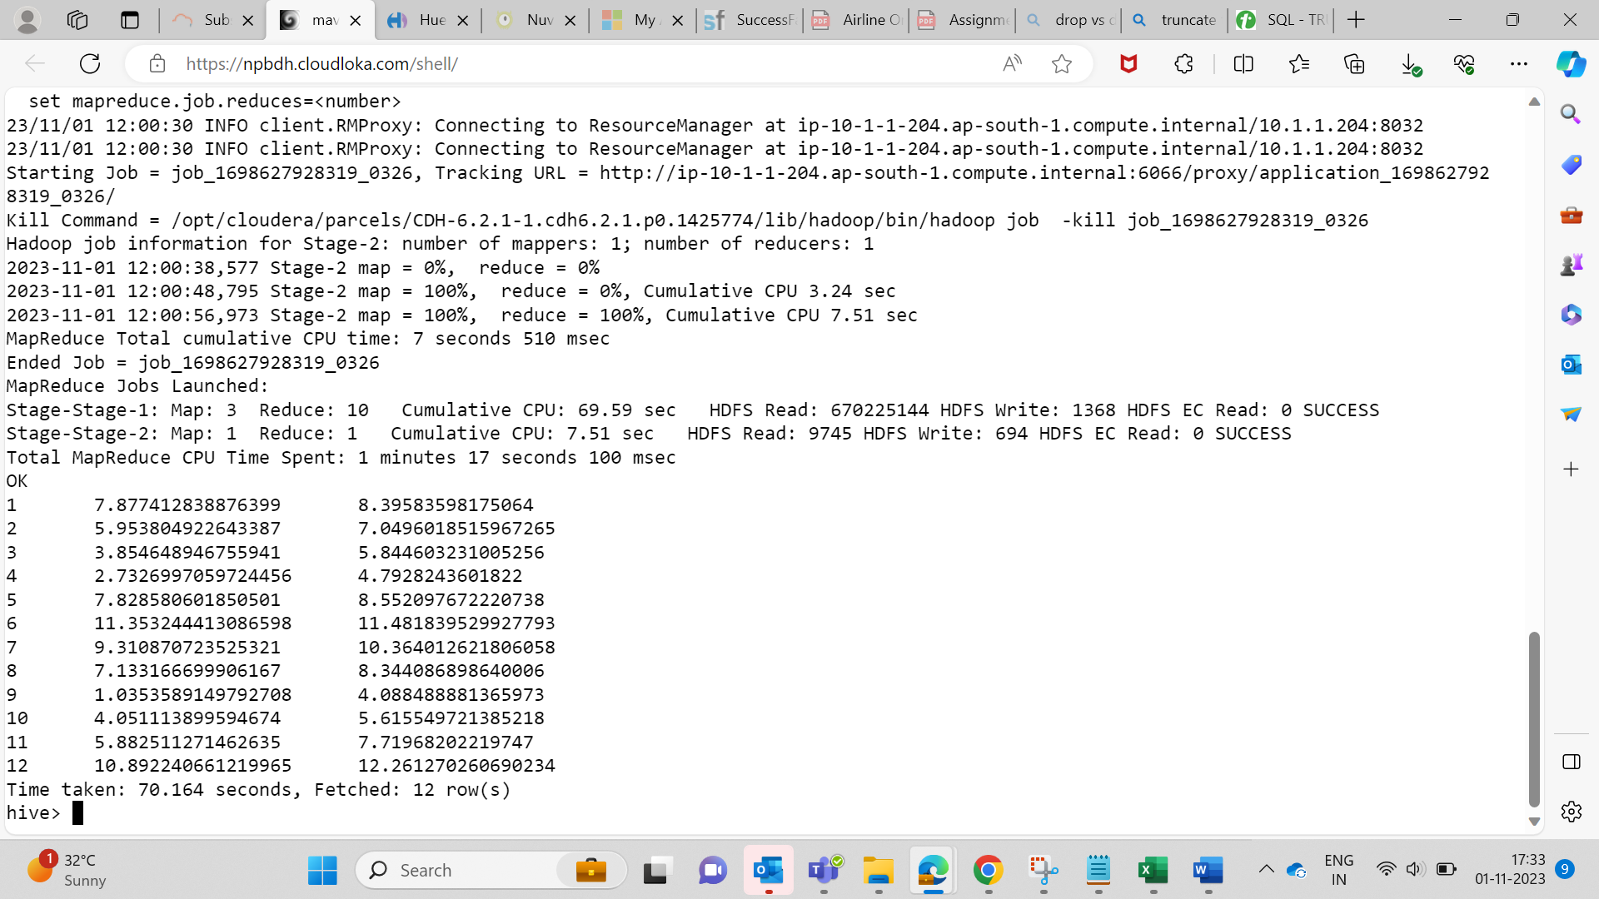



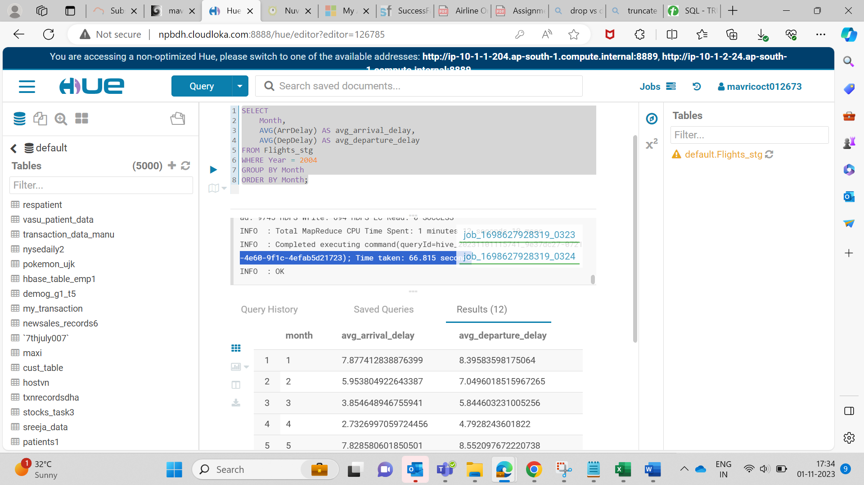  
**3. Improving the performance of Hive tables - Parquet**

**Format**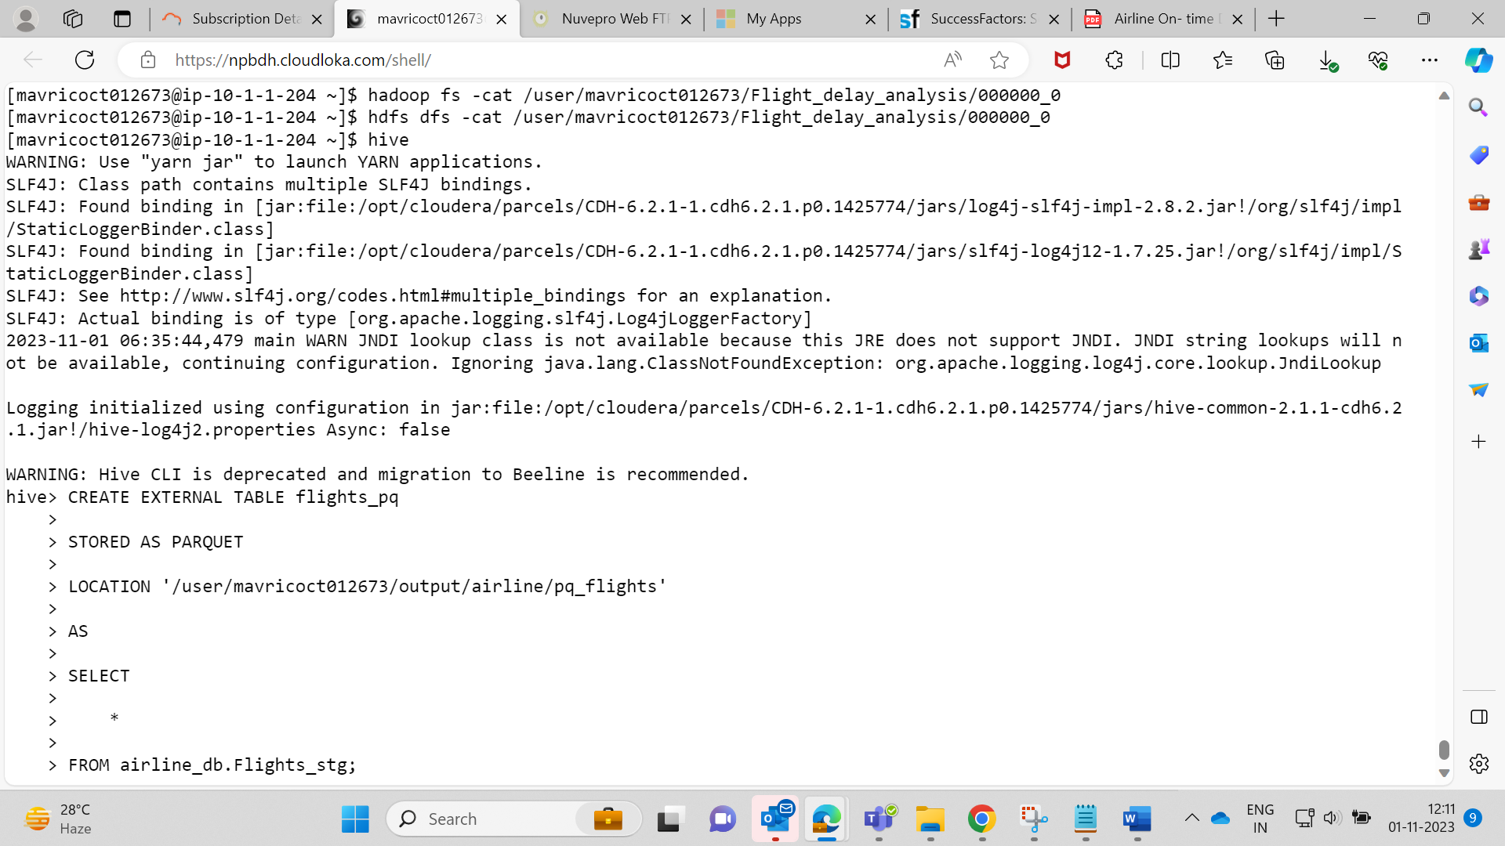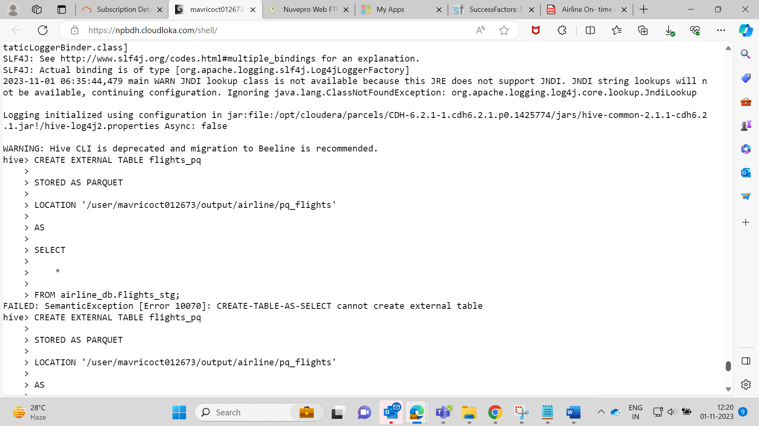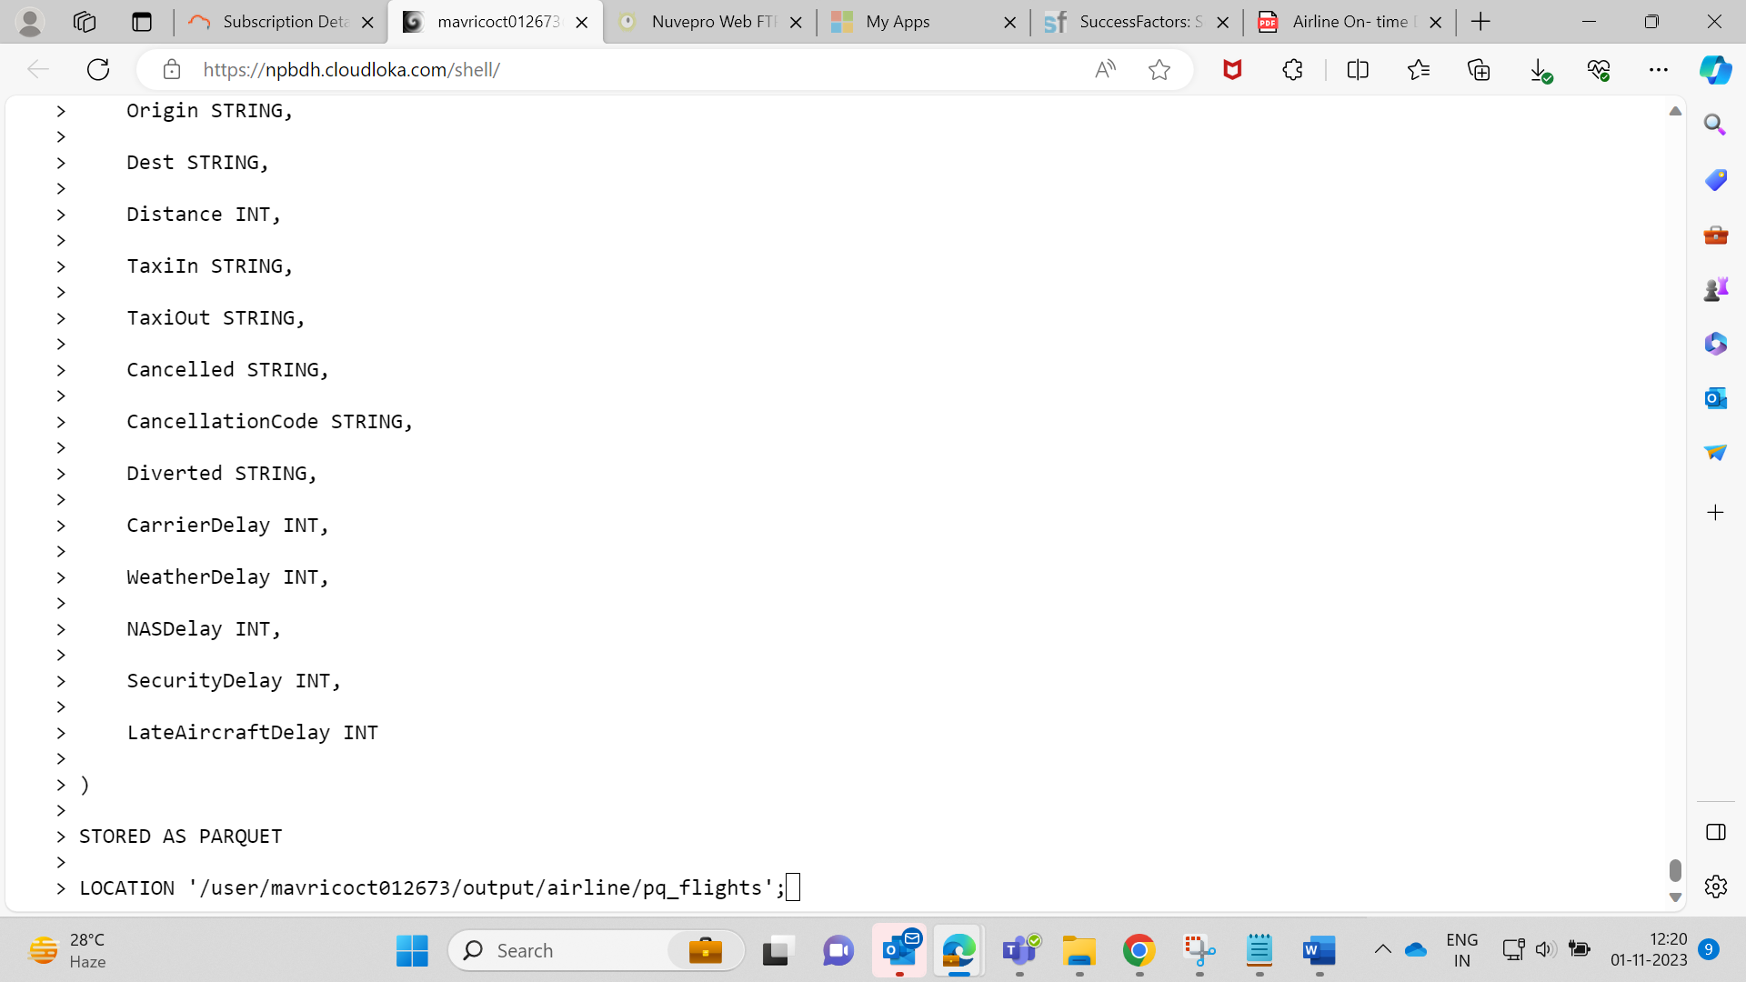  
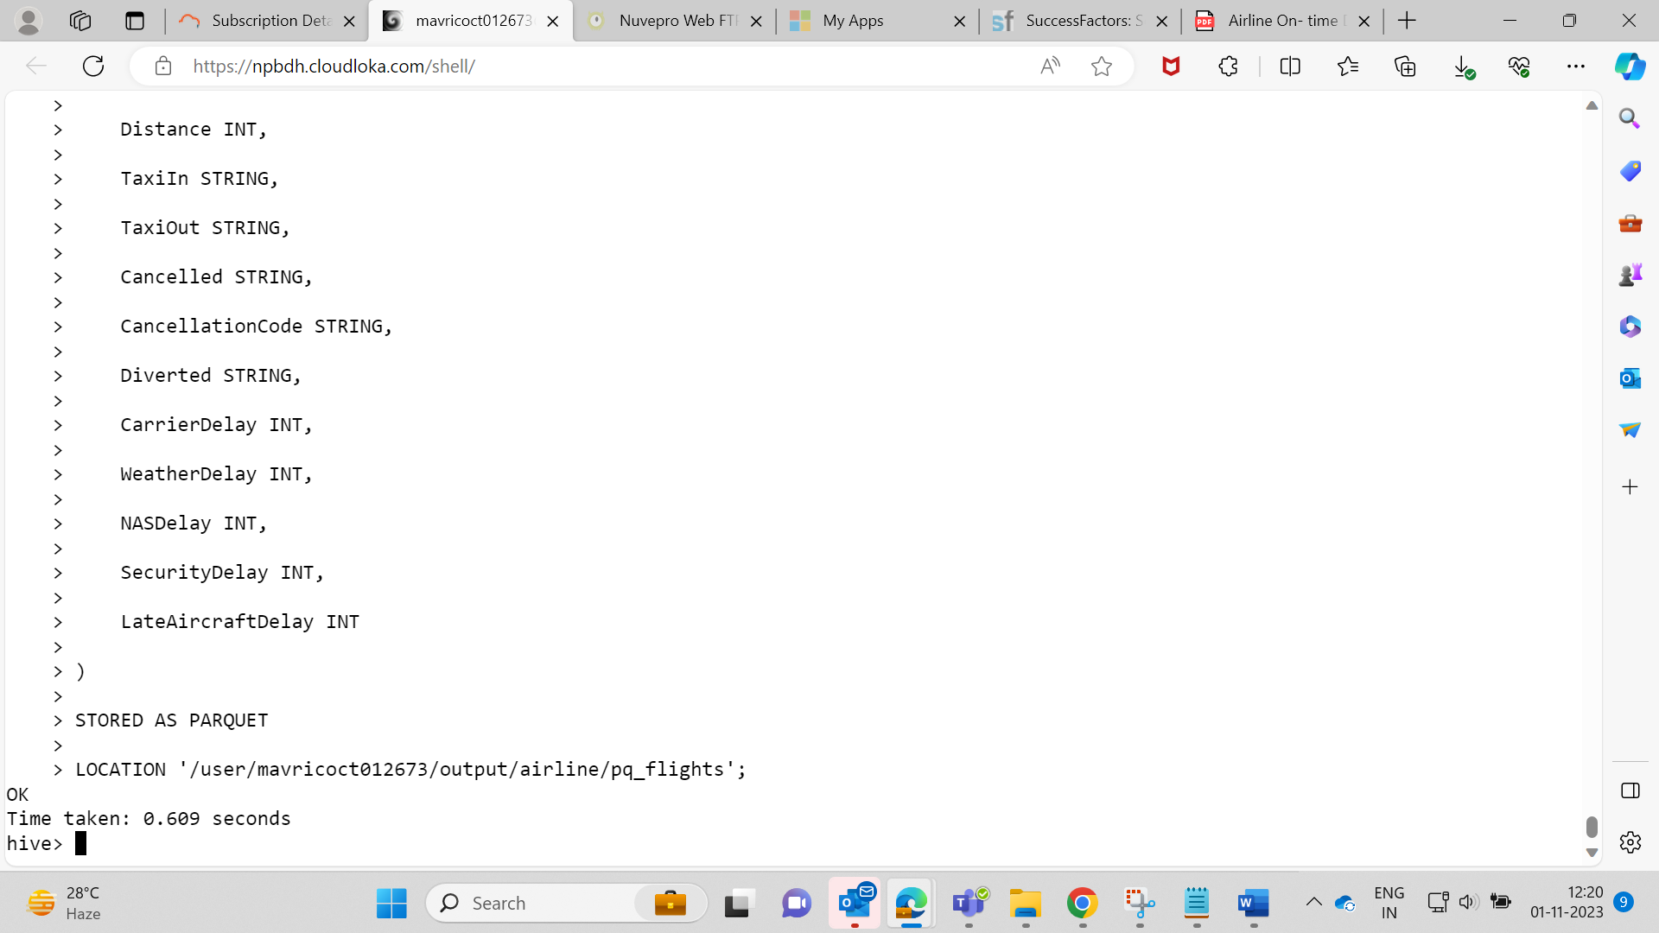  
  
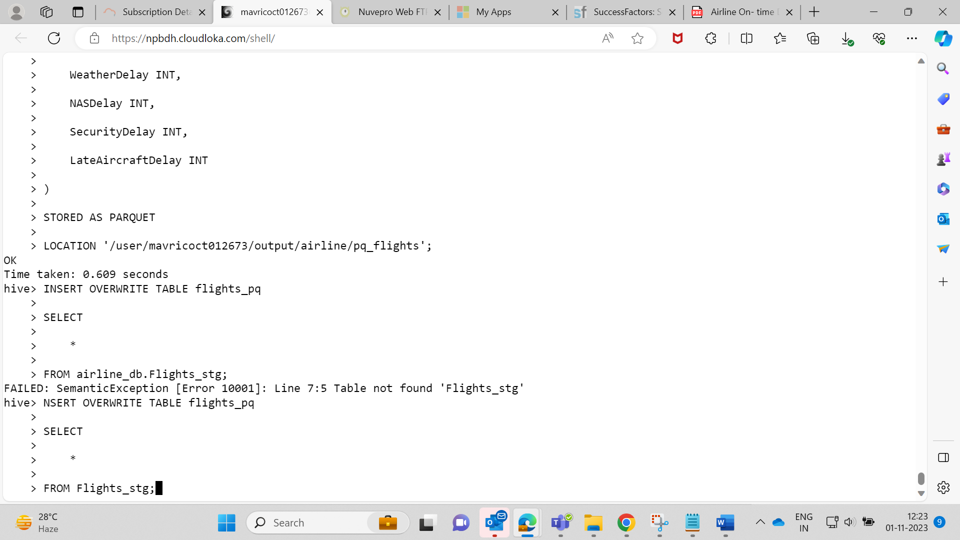  
  
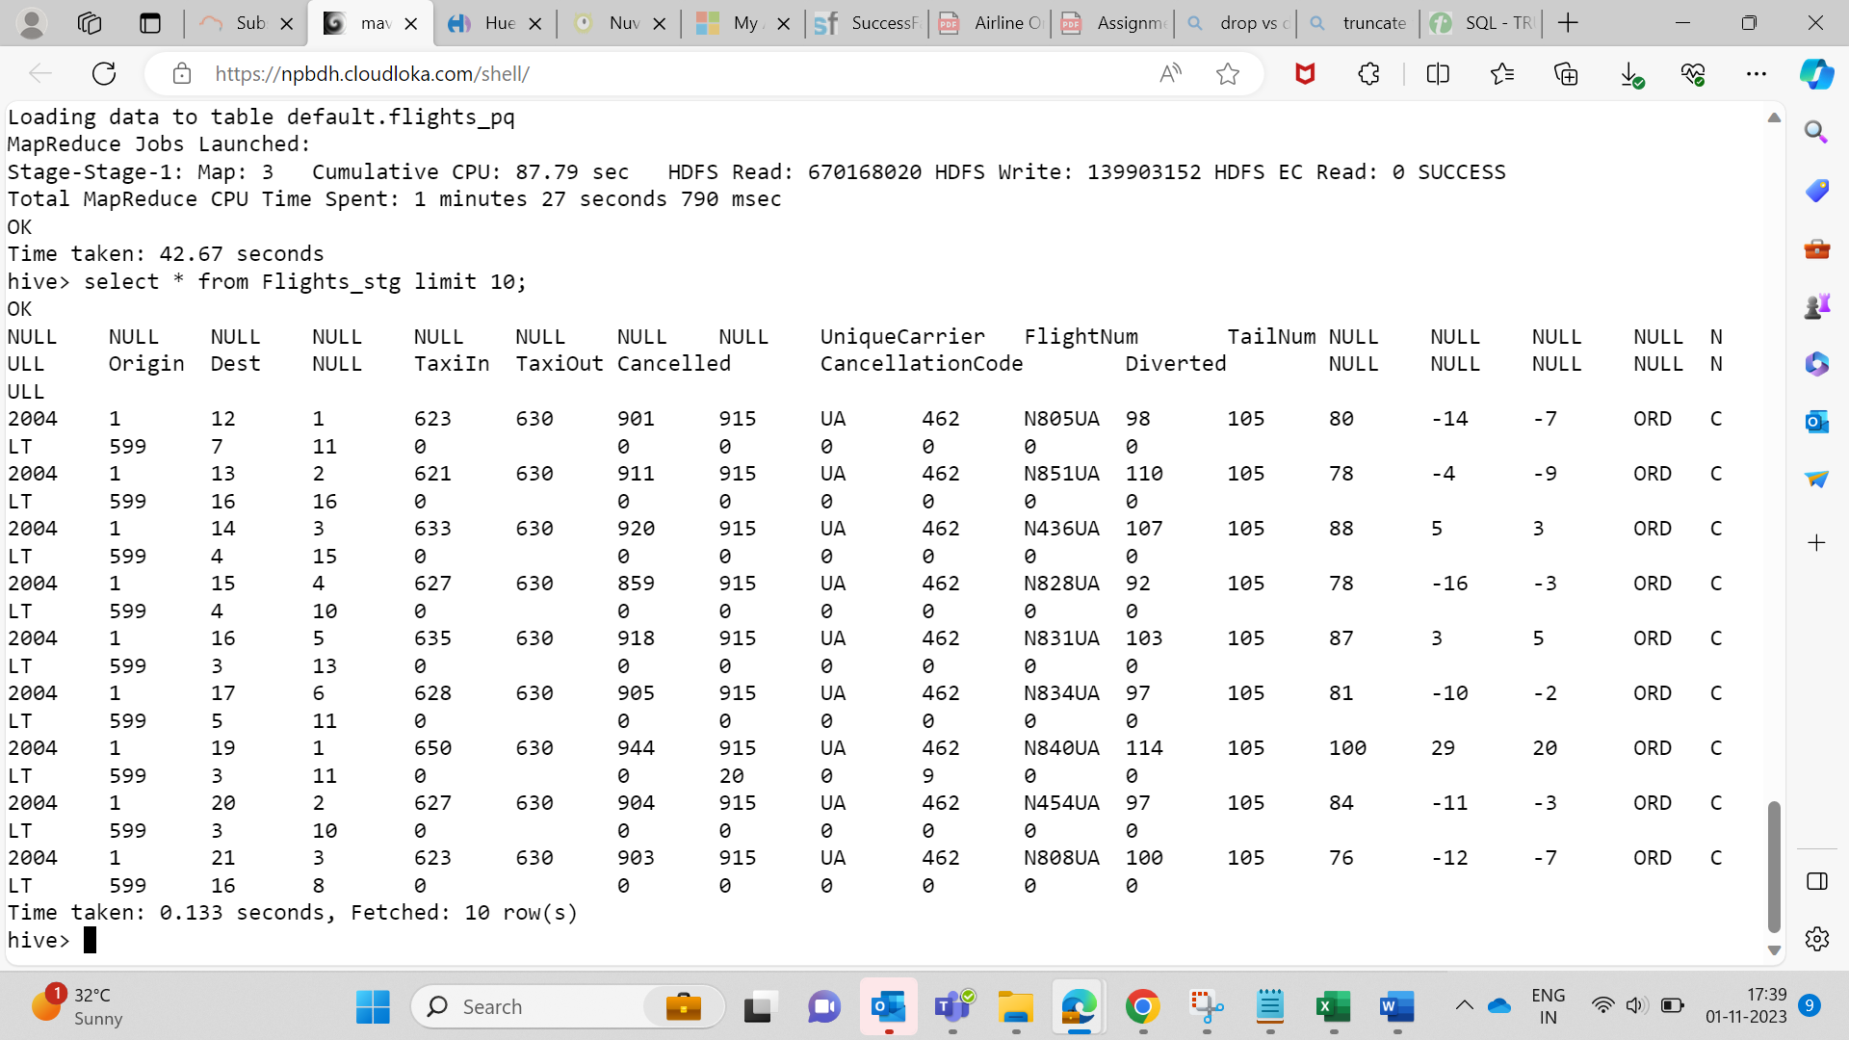  
  
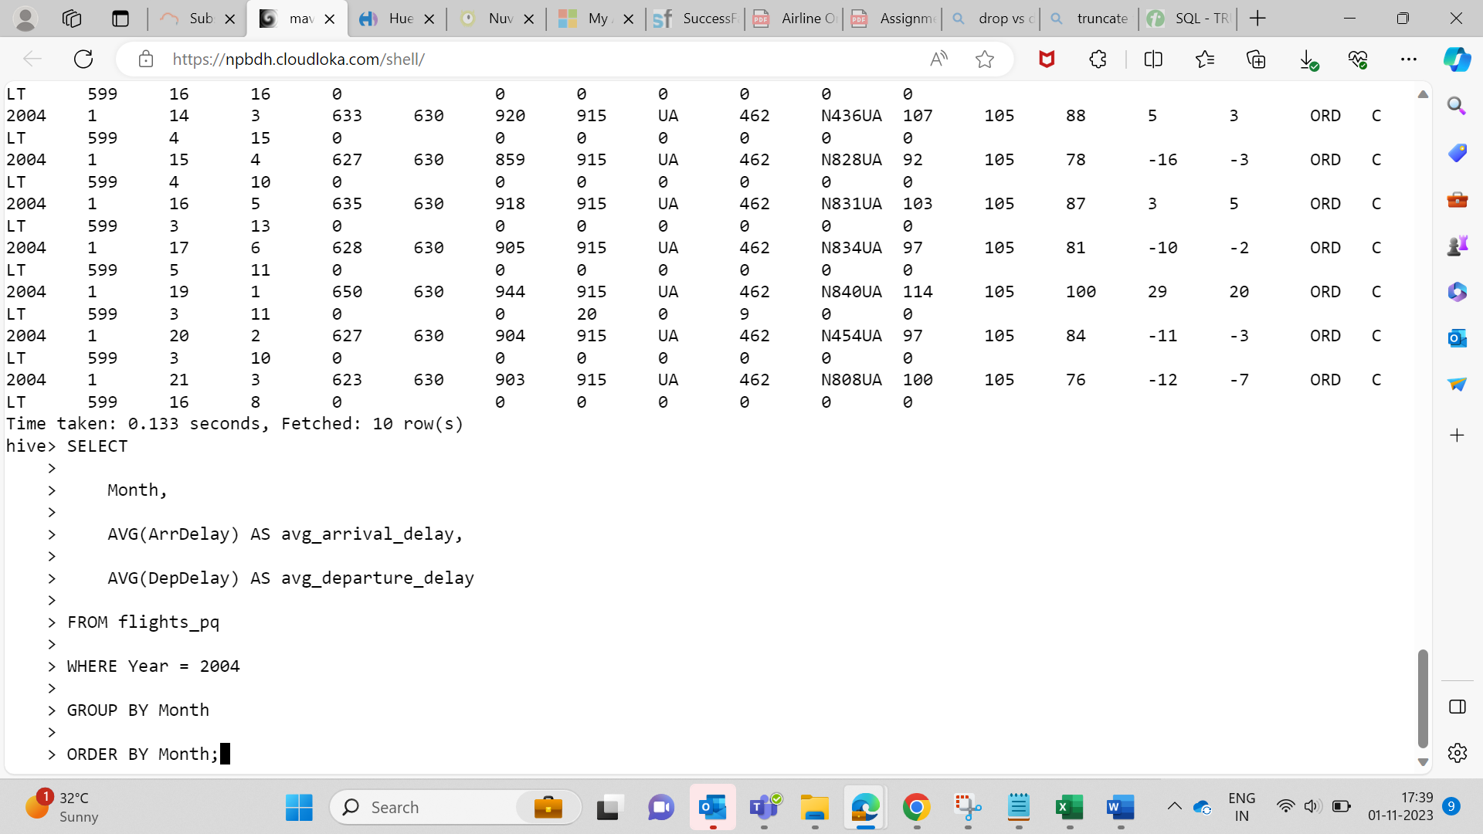  
  
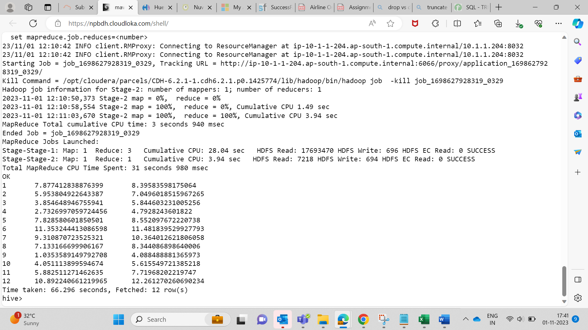

**in – Parquet Query is executed faster than Normal table.**